Moral Dilemmas
Name
Institution
Date

Moral Dilemmas
Part 1
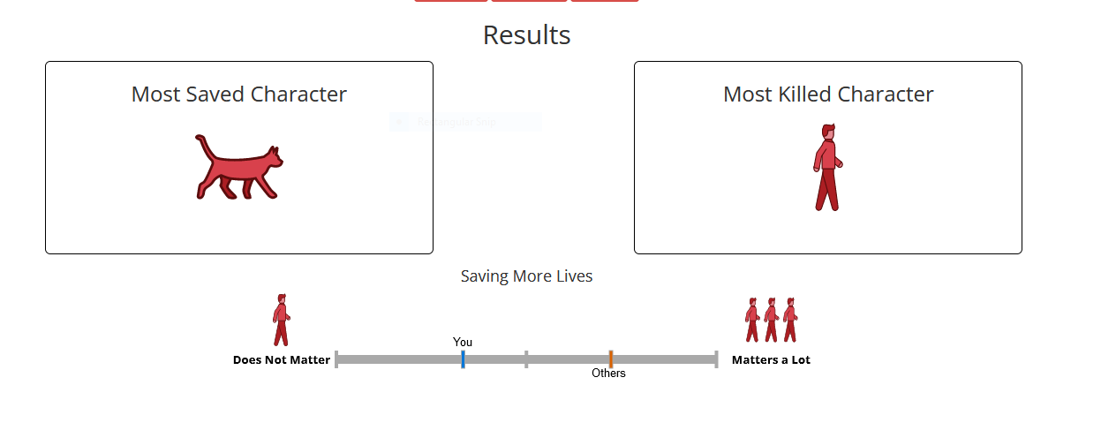
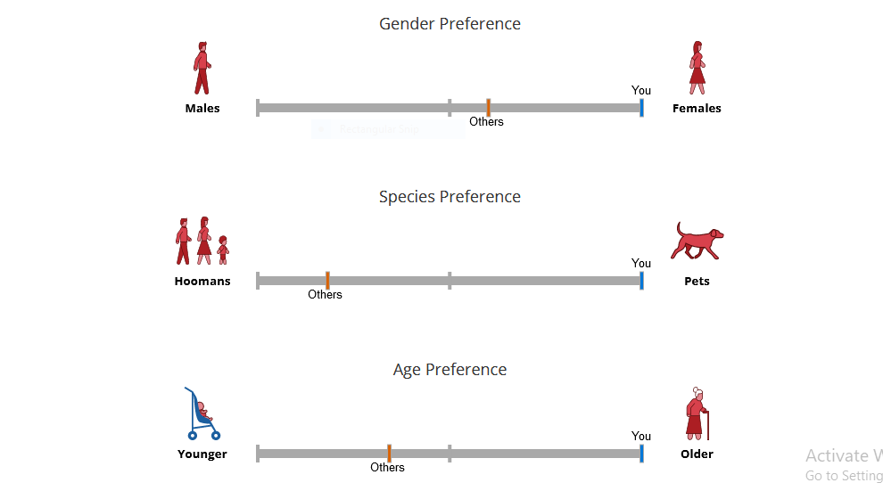

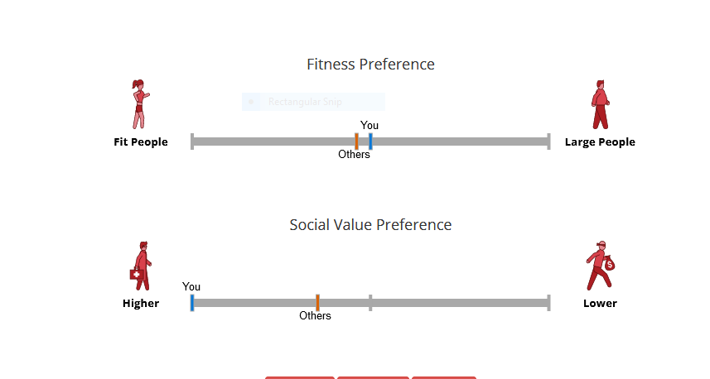
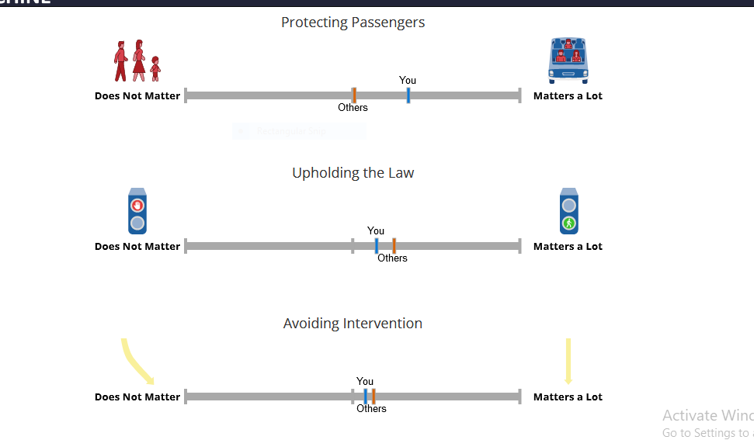

https://www.moralmachine.net/
- Which areas were identified as factors you considered more than others?
The areas that were identified as factors that I considered more than others were, Protecting Passengers, Gender Preference, Species Preference, Age Preference, Fitness Preference, and Social Value Preference.
- Do your results reflect what you expected? Which result(s) did you find most surprising about yourself and/or about others?
The results were not a reflection of what I expected, and thus they surprised me a lot. The results that I found most surprising about myself were Saving More Lives, Upholding the Law, Gender Preference, Species Preference, Age Preference, Fitness Preference, and Social Value Preference. I was surprised by these results because supposing I was the one giving judgment, they would have been completely opposite. One of my characters is that I do not entertain confrontation mostly, and thus when the results indicated, “It doesn’t matter,” I was shocked because this was contrary to my expectation. For example, the results indicated that Saving More Lives did not matter to me. This was totally contrasting to me since I value life, and therefore I would have saved more lives. In addition, the results indicated that I did not matter about Upholding the Law. This was also surprising to me because I am a law-abiding individual. Besides being a law-abiding person, I also fear confrontations with the law enforcers, and thus I would have upheld the law. I do not like confrontations that involve physical interactions, specifically face-to-face interactions.
The age preference would have also mattered to me. This is so because young individuals represent the future of families, populations or communities, and nations, and therefore in order to ensure the continuity of families, populations or communities, and nations, it would have been a better notion to save the younger one. The results of Gender Preference were also shocking to me because they indicated that males mattered most to be. I value all individuals in equal measures because every person, whether male or female, has their own unique value. The one that surprised me the most was the results of Gender Preference. These results indicated that pets mattered to me most compared to human beings. Pets are valuable to human beings, but their value and importance cannot be preferred to that of human beings. As a human being, I need fellow human beings more than I need pets in my life. The results of the Social Value Preference were also surprising to me because they indicated that I largely preferred individuals with less income. I place equal measures on all individuals, irrespective of social class or economic background, provided that what they are doing is moral.
- Based on the readings in this week's 3.0 Weekly Overview, which ethical paradigm do you think best defines how you make moral choices?
I think the ethical paradigm that best defines how I make moral choices is utilitarianism. Utilitarianism is a theory of ethics centered on the notion that the actions of people are morally right if they yield benefits to a significant number of people (Ethics Unwrapped, 2021). Utilitarians believe that the utility of an action determines its value. Therefore, as I embark on my moral choices, I always ensure that they will result in huge benefits to the largest number of people.
- According to the video Moral Machines: How culture changes values, what moral challenge will the developers of self-driving cars face when designing them for the international market?
The significant moral challenge that the developers of the self-driving car will face while designing these cars for the international market is the basic safety of each and every person (Nature Video, 2018). Notably, the developers will have to ensure that they uphold the safety of all people, may it be pedestrians or passengers, irrespective of any differences. Before releasing the self-driving cars into the international market, the developers should have done pilot testing to ensure that the cars protect public safety. The developers will have to uphold safety because failure to, they will be liable for any damages that may cost them significantly.
Part 3
- Based on what you have learned about the cultural influence on moral decisions, explain how your culture influences your moral choices.
My cultural factors strongly influence my moral judgments. Ideally, when one is raised in a particular culture, they learn to do things a certain way. To put it another way, they have to respond appropriately to any given situation. The trolley dilemma scenario put lives in jeopardy (BBC Radio 4, 2014). Thus I was torn between two options. If it had been up to me, everyone would have lived. However, someone had to pay the price. I did not want to kill anyone, but there was no other option if I wanted to save a life. My only option was to activate the switch and save the five people.
- What cultural layers have played a part in constructing your sense of right and wrong?
As a result of my upbringing, I believe it is heavily impacted by American capitalism. This is so because of my proclivity for putting the larger good or productivity ahead of what makes individuals feel better. Most of the time, I believe an individual’s background has a bearing on how they make moral choices. Most people would pick one item over another based on whether they believe something is right or wrong. Doing the right thing is not always better for business or saves fewer lives, as seen in the video. This is not always the greatest strategy.

References
BBC Radio 4. (2014). The Trolley Problem. Retrieved from https://www.youtube.com/watch?v=bOpf6KcWYyw
Ethics Unwrapped. (2021). Utilitarianism. Retrieved from https://ethicsunwrapped.utexas.edu/glossary/utilitarianism
https://www.moralmachine.net/
https://www.moralmachine.net/
Nature Video. (2018). Moral Machines: How culture changes values. You Tube. Retrieved from https://www.youtube.com/watch?v=jPo6bby-Fcg

